**MOTHER THERESA INSTITUTE OF ENGINEERING AND TECHNOLOGY**



# (AUTONUMOUS)

**(Approved by AICTE, New Delhi and Affiliated to JNTUA, Ananthapuramu-515002)**

**(NAAC Accredited with A+ &An ISO 9001:2015 Certified Institute)**

**Melumoi (Post), Palamaner-517408.**

**(Email:** [**mtieat@gmail.com**](mailto:mtieat@gmail.com)**,** [**hodcseds@mtieat.org**](mailto:hodcseds@mtieat.org) **Website:** [**www.mtieat.org**](http://www.mtieat.org/)**)**

***Department of***

***CSE (DATA SCIENCE)***

***Laboratory Manual for B.Tech III Year & II Semester***

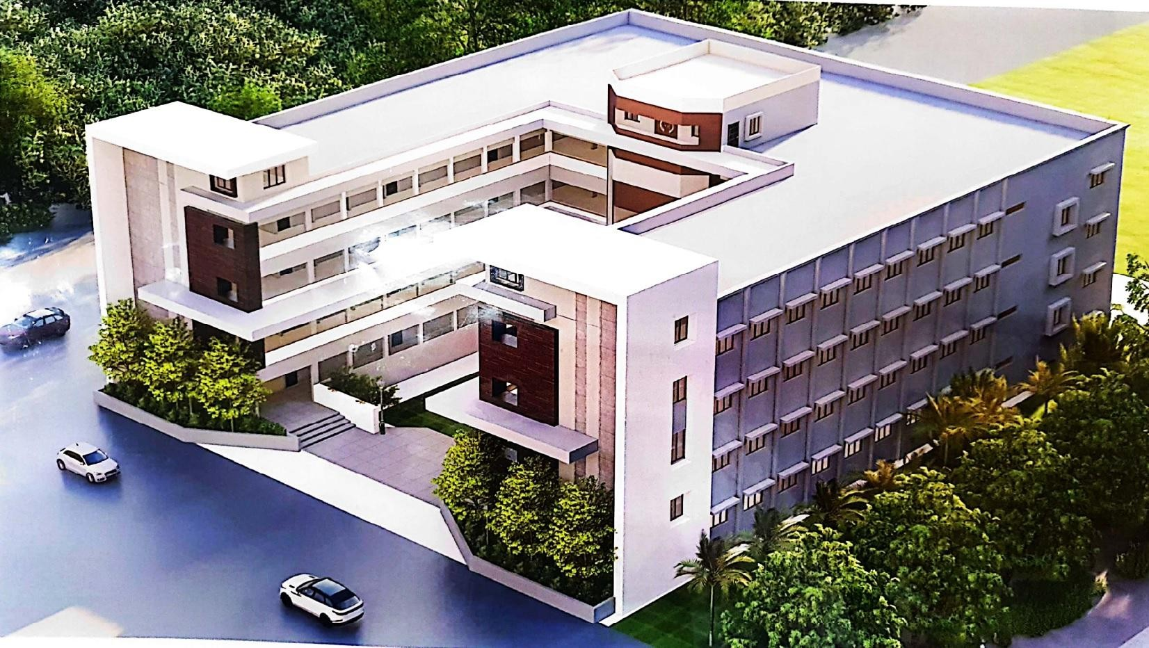

**Course Name :** Machine Learning Lab

**Course Code :** 20A05602P

***(R20 REGULATION)***



***Department of CSE (Data Science)***

***LABORATORY MANUAL***

***For***

B.Tech III Year II Semester (R20 Regulation)

**Course Name :** Machine Learning Lab

**Course Code :** 20A05602P **Academic Year :** 2024-25 **Batch :** 2022-26

**PREPARED BY: VERIFIED BY:**

SHIVA KUMAR E, Asst. Prof., Dept. of CSE (DS) A. REDDY PRASAD, Assoc. Prof.,

M. STANLYWIT , Asst. Prof., Dept. of CSE (DS) Dept. of CSE (DS)

# PREFACE

### Department Vision:

To promote quality education with industry collaboration and to enable students with intellectual skills to succeed in globally competitive environment.

### Department Mission:

* To educate the students with strong fundamentals in the areas of Artificial Intelligence and Data Science.
* Provide multi-disciplinary research and innovation driven academic environment to meet the global demands.
* Foster the spirit of lifelong learning in students through practical and social exposure beyond the classroom.

### Programme Educational Objectives (PEO):

Program Educational Objectives describe the career and professional accomplishments in five years after graduation that the program is preparing graduates to achieve.

1. Graduates will have solid basics in Mathematics, Programming, Machine Learning, Artificial Intelligence and Data Science Fundamentals and Advancements to solve technical problems.
2. Graduates will have the capability to apply their acquired knowledge and skills to solve the issues in real world Artificial Intelligence and Data Science sectors and to develop feasible and viable systems.
3. Graduates will have the potential to participate in life-long learning through professional developments for societal needs with ethical values.

### Programme Outcomes (POs):

Program Outcome describes the knowledge, skills and attitudes the students should have at the end of a four year engineering program.

Engineering Graduates will be able to:

1. Engineering Knowledge: Apply the knowledge of mathematics, science, engineering fundamentals and an engineering specialization to the solution of complex engineering problems.
2. Problem Analysis: Identify, formulate, review research literature, and analyze complex engineering problems reaching substantiated conclusions using first principles of mathematics, natural sciences, and engineering sciences.
3. Design / Development of solutions: Design solutions for complex engineering problems and design system components or processes that meet the specified needs with appropriate consideration for the public health and safety, and the cultural, societal, and environmental considerations.
4. Conduct investigations of complex problems: Use research-based knowledge and research methods, including design of experiments, analysis and interpretation of data, and synthesis of the information to provide valid conclusions.
5. Modern tool usage: Create, select, and apply appropriate techniques, resources, and modern engineering and IT tools including prediction and modeling of complex engineering activities with an understanding of the limitations.
6. The engineer and society: Apply reasoning informed by the contextual knowledge to assess societal, health, safety, legal and cultural issues and the consequent responsibilities relevant to the professional engineering practice.
7. Environment and Sustainability: Understand the impact of the professional engineering solutions to societal and environmental contexts, and demonstrate the knowledge of, and need for sustainable development.
8. Ethics: Apply ethical principles and commit to professional ethics and responsibilities and norms of the engineering practice.
9. Individual and team work: Function effectively as an individual and as a member or leader in diverse teams, and in multidisciplinary settings.
10. Communication: Communicate effectively on complex engineering activities with the engineering community and with society at large, such as, being able to comprehend and write effective reports and design documentation, make effective presentations, and give and receive clear instructions.
11. Project management and finance: Demonstrate knowledge and understanding of the engineering management principles and apply these to one’s own work, as a member and leader in a team, to manage projects and in multidisciplinary environments.
12. Lifelong learning: Recognize the need for and have the preparation and ability to engage in independent and lifelong learning in the broadest context of technological change.

### Programme Specific Outcomes (PSOs):

Program Specific Outcomes are statements that describe what the graduates of a specific engineering program should be able to do.

1. Ability to implement innovative, cost effective, energy efficient and eco-friendly integrated solutions for existing and new applications using Internet of Things.
2. Graduates will possess the additional skills in network security and IT infrastructure in Cyberspace.
3. Develop, test and maintain software system for business and other applications that meet the automation needs of the society and industry.

**COURSE OBJECTIVES AND OUTCOMES**

### Course Objectives:

* + Make use of datasets in implementing the machine learning Algorithms.
  + Implement the machine learning concepts in any suitable language

### Course Outcomes:

On completion of this course, the students will be able to:

**CO1:** Understand the mathematical and statistical perspective of machine learning algorithms through python programming

**CO2:** Appreciate the importance of Data Visualization in the data analytics solution.

**CO3:** Derive insights using machine learning. **CO4:** Learn various classification algorithms **CO5:** Analyze various Regression techniques.

|  |  |  |  |  |  |  |  |  |  |  |  |  |  |  |  |
| --- | --- | --- | --- | --- | --- | --- | --- | --- | --- | --- | --- | --- | --- | --- | --- |
| **Mapping of COs with POs and PSOs** | | | | | | | | | | | | | | | |
| **CO** | **PO1** | **PO2** | **PO3** | **PO4** | **PO5** | **PO6** | **PO7** | **PO8** | **PO9** | **PO10** | **PO11** | **PO12** | **PSO1** | **PSO2** | **PSO3** |
| **CO1** | 3 | 3 | 2 | 2 | 3 | 2 | 2 | 0 | 1 | 2 | 1 | 2 | 3 | 3 | 3 |
| **CO2** | 3 | 3 | 3 | 3 | 3 | 1 | 1 | 0 | 1 | 1 | 1 | 1 | 3 | 2 | 2 |
| **CO3** | 3 | 3 | 3 | 3 | 2 | 2 | 1 | 0 | 2 | 1 | 1 | 1 | 3 | 3 | 2 |
| **CO4** | 2 | 2 | 2 | 2 | 3 | 1 | 1 | 0 | 1 | 1 | 1 | 2 | 3 | 2 | 2 |
| **CO5** | 3 | 2 | 3 | 3 | 3 | 2 | 2 | 0 | 1 | 2 | 2 | 1 | 3 | 2 | 1 |
| **TOT** | 3 | 3 | 2 | 2 | 3 | 2 | 2 | 0 | 1 | 2 | 1 | 2 | 3 | 3 | 3 |

### Implement and demonstrate the FIND-S algorithm for finding the most specific hypothesis based on a given set of training data samples. Read the training data from a .CSV file.

**Aim:** To Implement demonstrate the FIND-S algorithm for finding the most specific hypothesis based on a given set of training data samples

### Algorithm/Procedure:

1. Initilize h to the most specific hypothesis in H
2. For each positive training instance x For each attribute contraint ai in h

If the contraint ai is satisfied by x then do nothing

Else

replace ai in h by the next more general constraint that is satisfied by x

1. Output the hypothesis h

### Program:

import csv a = []

with open('enjoysport.csv', 'r') as csvfile: next(csvfile)

for row in csv.reader(csvfile): a.append(row)

print(a)

print("\nThe total number of training instances are : ",len(a)) num_attribute = len(a[0])-1

print("\nThe initial hypothesis is : ") hypothesis = ['0']*num_attribute print(hypothesis)

for i in range(0, len(a)):

if a[i][num_attribute] == 'yes':

print ("\nInstance ", i+1, "is", a[i], " and is Positive Instance") for j in range(0, num_attribute):

if hypothesis[j] == '0' or hypothesis[j] == a[i][j]: hypothesis[j] = a[i][j]

else:

hypothesis[j] = '?'

print("The hypothesis for the training instance", i+1, " is: " , hypothesis, "\n")

if a[i][num_attribute] == 'no':

print ("\nInstance ", i+1, "is", a[i], " and is Negative Instance Hence Ignored") print("The hypothesis for the training instance", i+1, " is: " , hypothesis, "\n")

print("\nThe Maximally specific hypothesis for the training instance is ", hypothesis)

### Expected Output:

[['sunny', 'warm', 'normal', 'strong', 'warm', 'same', 'yes'], ['sunny', 'warm', 'high'

, 'strong', 'warm', 'same', 'yes'], ['rainy', 'cold', 'high', 'strong', 'warm', 'change

', 'no'], ['sunny', 'warm', 'high', 'strong', 'cool', 'change', 'yes']] The total number of training instances are : 4

The initial hypothesis is :

['0', '0', '0', '0', '0', '0']

Instance 1 is ['sunny', 'warm', 'normal', 'strong', 'warm', 'same', 'yes'] and is Pos itive Instance

The hypothesis for the training instance 1 is: ['sunny', 'warm', 'normal', 'strong', 'warm', 'same']

Instance 2 is ['sunny', 'warm', 'high', 'strong', 'warm', 'same', 'yes'] and is Posit ive Instance

The hypothesis for the training instance 2 is: ['sunny', 'warm', '?', 'strong', 'warm ', 'same']

Instance 3 is ['rainy', 'cold', 'high', 'strong', 'warm', 'change', 'no'] and is Nega tive Instance Hence Ignored

The hypothesis for the training instance 3 is: ['sunny', 'warm', '?', 'strong', 'warm ', 'same']

Instance 4 is ['sunny', 'warm', 'high', 'strong', 'cool', 'change', 'yes'] and is Pos itive Instance

The hypothesis for the training instance 4 is: ['sunny', 'warm', '?', 'strong', '?', '?']

The Maximally specific hypothesis for the training instance is ['sunny', 'warm', '?', 'strong', '?', '?']

**Result:**

## SIGNATURE OF LAB IN-CHARGE

### For a given set of training data examples stored in a .CSV file, implement and demonstrate the Candidate-Elimination algorithm to output a description of the set of all hypotheses consistent with the training examples.

**Aim:** implement and demonstrate the Candidate-Elimination algorithm.

### Algorithm/Procedure:

For each training example d, do: If d is positive example

Remove from G any hypothesis h inconsistent with d For each hypothesis s in S not consistent with d:

Remove s from S

Add to S all minimal generalizations of s consistent with d and having a generalization in G Remove from S any hypothesis with a more specific h in S

If d is negative example

Remove from S any hypothesis h inconsistent with d For each hypothesis g in G not consistent with d:

Remove g from G

Add to G all minimal specializations of g consistent with d and having a specialization in S Remove from G any hypothesis having a more general hypothesis in G

### Program:

import numpy as np import pandas as pd

data = pd.read_csv(path+'/enjoysport.csv') concepts = np.array(data.iloc[:,0:-1]) print("\nInstances are:\n",concepts)

target = np.array(data.iloc[:,-1]) print("\nTarget Values are: ",target) def learn(concepts, target):

specific_h = concepts[0].copy() print("\nInitialization of specific_h and genearal_h") print("\nSpecific Boundary: ", specific_h)

general_h = [["?" for i in range(len(specific_h))] for i in range(len(specific_h))] print("\nGeneric Boundary: ",general_h)

for i, h in enumerate(concepts): print("\nInstance", i+1 , "is ", h) if target[i] == "yes":

print("Instance is Positive ") for x in range(len(specific_h)):

if h[x]!= specific_h[x]: specific_h[x] ='?' general_h[x][x] ='?'

if target[i] == "no": print("Instance is Negative ") for x in range(len(specific_h)):

if h[x]!= specific_h[x]:

general_h[x][x] = specific_h[x] else:

general_h[x][x] = '?'

print("Specific Bundary after ", i+1, "Instance is ", specific_h) print("Generic Boundary after ", i+1, "Instance is ", general_h) print("\n")

indices = [i for i, val in enumerate(general_h) if val == ['?', '?', '?', '?', '?', '?']] for i in indices:

general_h.remove(['?', '?', '?', '?', '?', '?']) return specific_h, general_h

s_final, g_final = learn(concepts, target)

print("Final Specific_h: ", s_final, sep="\n") print("Final General_h: ", g_final, sep="\n")

### Expected Output:

Instances are:

[['sunny' 'warm' 'normal' 'strong' 'warm' 'same']

['sunny' 'warm' 'high' 'strong' 'warm' 'same']

['rainy' 'cold' 'high' 'strong' 'warm' 'change']

['sunny' 'warm' 'high' 'strong' 'cool' 'change']] Target Values are: ['yes' 'yes' 'no' 'yes'] Initialization of specific_h and genearal_h

Specific Boundary: ['sunny' 'warm' 'normal' 'strong' 'warm' 'same']

Generic Boundary: [['?', '?', '?', '?', '?', '?'], ['?', '?', '?', '?', '?', '?'], ['?

', '?', '?', '?', '?', '?'], ['?', '?', '?', '?', '?', '?'], ['?', '?', '?', '?', '?', '?'], ['?', '?', '?', '?', '?', '?']]

Instance 1 is ['sunny' 'warm' 'normal' 'strong' 'warm' 'same'] Instance is Positive

Specific Bundary after 1 Instance is ['sunny' 'warm' 'normal' 'strong' 'warm' 'same'] Generic Boundary after 1 Instance is [['?', '?', '?', '?', '?', '?'], ['?', '?', '?', '?', '?', '?'], ['?', '?', '?', '?', '?', '?'], ['?', '?', '?', '?', '?', '?'], ['?',

'?', '?', '?', '?', '?'], ['?', '?', '?', '?', '?', '?']]

Instance 2 is ['sunny' 'warm' 'high' 'strong' 'warm' 'same'] Instance is Positive

Specific Bundary after 2 Instance is ['sunny' 'warm' '?' 'strong' 'warm' 'same'] Generic Boundary after 2 Instance is [['?', '?', '?', '?', '?', '?'], ['?', '?', '?',

'?', '?', '?'], ['?', '?', '?', '?', '?', '?'], ['?', '?', '?', '?', '?', '?'], ['?', '?', '?', '?', '?', '?'], ['?', '?', '?', '?', '?', '?']]

Instance 3 is ['rainy' 'cold' 'high' 'strong' 'warm' 'change'] Instance is Negative

Specific Bundary after 3 Instance is ['sunny' 'warm' '?' 'strong' 'warm' 'same'] Generic Boundary after 3 Instance is [['sunny', '?', '?', '?', '?', '?'], ['?', 'warm ', '?', '?', '?', '?'], ['?', '?', '?', '?', '?', '?'], ['?', '?', '?', '?', '?', '?'],

['?', '?', '?', '?', '?', '?'], ['?', '?', '?', '?', '?', 'same']]

Instance 4 is ['sunny' 'warm' 'high' 'strong' 'cool' 'change'] Instance is Positive

Specific Bundary after 4 Instance is ['sunny' 'warm' '?' 'strong' '?' '?']

Generic Boundary after 4 Instance is [['sunny', '?', '?', '?', '?', '?'], ['?', 'warm ', '?', '?', '?', '?'], ['?', '?', '?', '?', '?', '?'], ['?', '?', '?', '?', '?', '?'],

['?', '?', '?', '?', '?', '?'], ['?', '?', '?', '?', '?', '?']]

Final Specific_h:

['sunny' 'warm' '?' 'strong' '?' '?'] Final General_h:

[['sunny', '?', '?', '?', '?', '?'], ['?', 'warm', '?', '?', '?', '?']]

**Result:**

## SIGNATURE OF LAB IN-CHARGE

### Write a program to demonstrate the working of the decision tree based ID3 algorithm.

**Use an appropriate data set for building the decision tree and apply this knowledge to classify a new sample.**

**Aim:** To demonstrate the working of the decision tree based ID3 algorithm

### Algorithm/Procedure:

ID3(Examples, Target_attribute, Attributes)

*Examples are the training examples.*

*Target_attribute is the attribute whose value is to be predicted by the tree. Attributes is a list of other attributes that may be tested by the learned decision tree. Returns a decision tree that correctly classifies the given Examples.*

*Create a Root node for the tree*

If all Examples are positive, Return the single-node tree Root, with label = + If all Examples are negative, Return the single-node tree Root, with label = - If Attributes is empty, Return the single-node tree Root,

with label = most common value of Target_attribute in Examples Otherwise Begin

A ← the attribute from Attributes that best* classifies Examples The decision attribute for Root ← A

For each possible value, vi, of A,

Add a new tree branch below Root, corresponding to the test A = vi Let Examples vi, be the subset of Examples that have value vi for A If Examples vi , is empty

Then below this new branch add a leaf node with

label = most common value of Target_attribute in Examples Else

below this new branch add the subtree

ID3(Examples vi, Targe_tattribute, Attributes – {A}))

End

Return Root

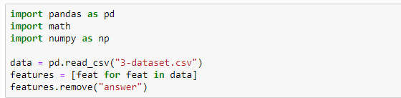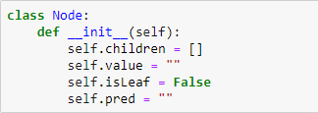**Program:**

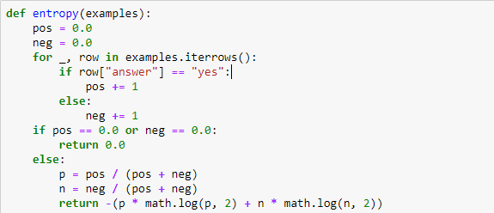

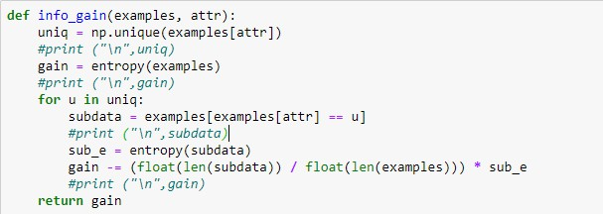

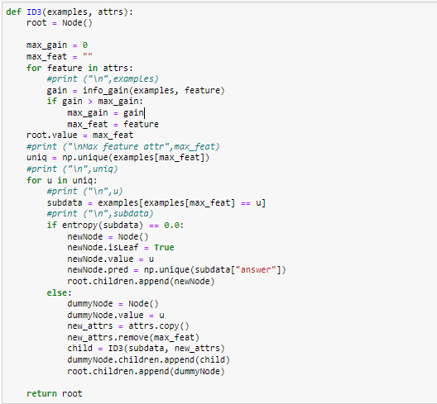

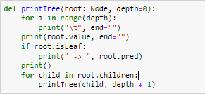

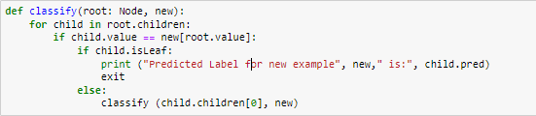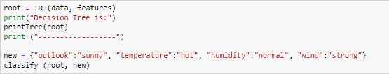

**Expected Output:**

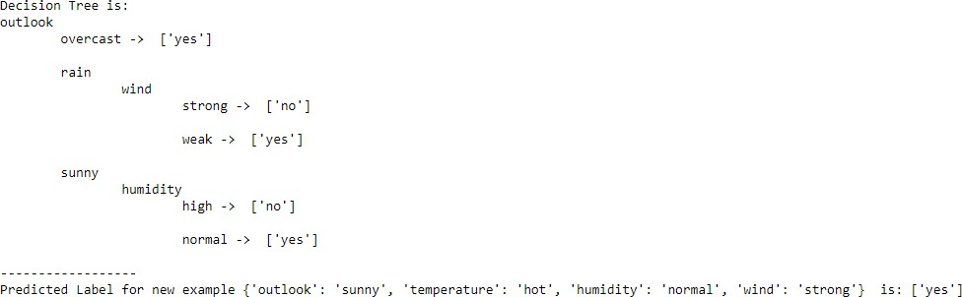

**Result:**

## SIGNATURE OF LAB IN-CHARGE

### Build an Artificial Neural Network by implementing the Back-propagation algorithm and test the same using appropriate data sets.

**Aim:** To Build an Artificial Neural Network by implementing the Back-propagation algorithm.

### Algorithm/Procedure:

1. Create a feed-forward network with ni inputs, nhidden hidden units, and nout output units.
2. Initialize all network weights to small random numbers
3. Until the termination condition is met, Do For each (𝑥, t), in training examples, Do

Propagate the input forward through the network:

* 1. Input the instance 𝑥, to the network and compute the output ou of every unit u in the network. Propagate the errors backward through the network
  2. For each network unit k, calculate its error term δk

https://www.vtupulse.com/wp-content/uploads/2021/06/image.png

* 1. For each network unit h, calculate its error term δh

https://www.vtupulse.com/wp-content/uploads/2021/06/image-1.png

* 1. Update each network weight wji

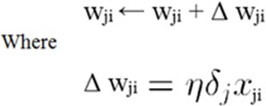

### Program:

import numpy as np

X = np.array(([2, 9], [1, 5], [3, 6]), dtype=float)

y = np.array(([92], [86], [89]), dtype=float)

X = X/np.amax(X,axis=0) #maximum of X array longitudinally y = y/100

#Sigmoid Function def sigmoid (x):

return 1/(1 + np.exp(-x))

#Derivative of Sigmoid Function def derivatives_sigmoid(x):

return x * (1 - x)

#Variable initialization

epoch=5 #Setting training iterations lr=0.1 #Setting learning rate

inputlayer_neurons = 2 #number of features in data set hiddenlayer_neurons = 3 #number of hidden layers neurons output_neurons = 1 #number of neurons at output layer #weight and bias initialization

wh=np.random.uniform(size=(inputlayer_neurons,hiddenlayer_neurons)) bh=np.random.uniform(size=(1,hiddenlayer_neurons)) wout=np.random.uniform(size=(hiddenlayer_neurons,output_neurons)) bout=np.random.uniform(size=(1,output_neurons))

#draws a random range of numbers uniformly of dim x*y for i in range(epoch):

#Forward Propogation hinp1=np.dot(X,wh) hinp=hinp1 + bh hlayer_act = sigmoid(hinp)

outinp1=np.dot(hlayer_act,wout) outinp= outinp1+bout

output = sigmoid(outinp) #Backpropagation

EO = y-output

outgrad = derivatives_sigmoid(output) d_output = EO * outgrad

EH = d_output.dot(wout.T)

hiddengrad = derivatives_sigmoid(hlayer_act)#how much hidden layer wts contributed to error d_hiddenlayer = EH * hiddengrad

wout += hlayer_act.T.dot(d_output) *lr # dotproduct of nextlayererror and currentlayerop wh += X.T.dot(d_hiddenlayer) *lr

print ("-----------Epoch-", i+1, "Starts ")

print("Input: \n" + str(X)) print("Actual Output: \n" + str(y)) print("Predicted Output: \n" ,output)

print ("-----------Epoch-", i+1, "Ends \n")

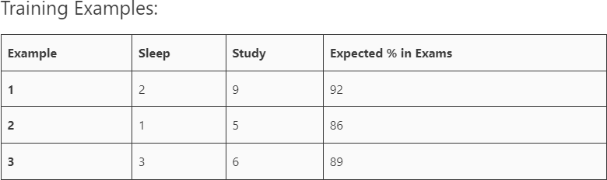print("Input: \n" + str(X)) print("Actual Output: \n" + str(y)) print("Predicted Output: \n" ,output)

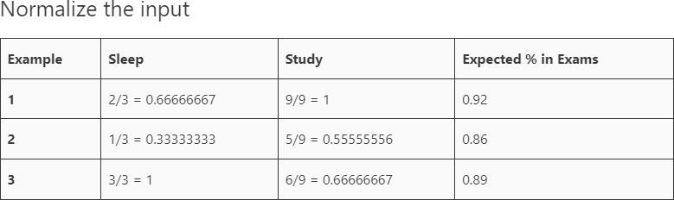

### Expected Output:

Epoch- 1 Starts

Input:

[[0.66666667 1. ]

[0.33333333 0.55555556]

[1. 0.66666667]]

Actual Output: [[0.92]

[0.86]

[0.89]]

Predicted Output: [[0.80441703]

[0.79630703]

[0.80433472]]

Epoch- 1 Ends

Epoch- 2 Starts

Input:

[[0.66666667 1. ]

[0.33333333 0.55555556]

[1. 0.66666667]]

Actual Output: [[0.92]

[0.86]

[0.89]]

Predicted Output: [[0.80545046]

[0.79728381]

[0.8053763 ]]

Epoch- 2 Ends

Epoch- 3 Starts

Input:

[[0.66666667 1. ]

[0.33333333 0.55555556]

[1. 0.66666667]]

Actual Output: [[0.92]

[0.86]

[0.89]]

Predicted Output: [[0.80646432]

[0.79824242]

[0.80639814]]

Epoch- 3 Ends

Epoch- 4 Starts

Input:

[[0.66666667 1. ]

[0.33333333 0.55555556]

[1. 0.66666667]]

Actual Output: [[0.92]

[0.86]

[0.89]]

Predicted Output: [[0.80745918]

[0.79918337]

[0.80740077]]

Epoch- 4 Ends

Epoch- 5 Starts

Input:

[[0.66666667 1. ]

[0.33333333 0.55555556]

[1. 0.66666667]]

Actual Output: [[0.92]

[0.86]

[0.89]]

Predicted Output: [[0.80843554]

[0.80010715]

[0.80838472]]

Epoch- 5 Ends

Input:

[[0.66666667 1. ]

[0.33333333 0.55555556]

[1. 0.66666667]]

Actual Output: [[0.92]

[0.86]

[0.89]]

Predicted Output: [[0.80843554]

[0.80010715]

[0.80838472]]

**Result:**

## SIGNATURE OF LAB IN-CHARGE

### Write a program to implement the naïve Bayesian classifier for a sample training data set stored as a .CSV file. Compute the accuracy of the classifier, considering few test data sets.

**Aim:** To implement the naïve Bayesian classifier

### Algorithm/Procedure:

Bayes’ Theorem is stated as:

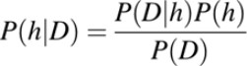

Where,

**P(h|D)** is the probability of hypothesis h given the data D. This is called the posterior probability.

**P(D|h)** is the probability of data d given that the hypothesis h was true

**P(h)** is the probability of hypothesis h being true. This is called the prior probability of h. P(D) is the probability of the data. This is called the prior probability of D

After calculating the posterior probability for a number of different hypotheses h, and is interested in finding the most probable hypothesis h ∈ H given the observed data D. Any such maximally probable hypothesis is called a maximum a posteriori (MAP) hypothesis.

Bayes theorem to calculate the posterior probability of each candidate hypothesis is hMAP is a MAP hypothesis provided.

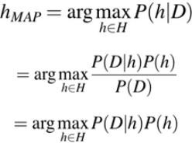

(Ignoring P(D) since it is a constant)

The data set used in this program is the **Pima Indians Diabetes problem**.

This data set is comprised of 768 observations of medical details for Pima Indians patents. The records describe instantaneous measurements taken from the patient such as their age, the number of times pregnant and blood workup. All patients are women aged 21 or older. All attributes are numeric, and their units vary from attribute to attribute.

The attributes are Pregnancies, Glucose, BloodPressure, SkinThickness, Insulin, BMI, DiabeticPedigreeFunction, Age, Outcome

Each record has a class value that indicates whether the patient suffered an onset of diabetes within 5 years of when the measurements were taken (1) or not (0)

### Program:

import csv import random import math

def loadcsv(filename):

lines = csv.reader(open(filename, "r")); dataset = list(lines)

for i in range(len(dataset)):

#converting strings into numbers for processing dataset[i] = [float(x) for x in dataset[i]]

return dataset

def splitdataset(dataset, splitratio): #67% training size

trainsize = int(len(dataset) * splitratio); trainset = []

copy = list(dataset);

while len(trainset) < trainsize:

#generate indices for the dataset list randomly to pick ele for training data index = random.randrange(len(copy)); trainset.append(copy.pop(index))

return [trainset, copy]

def separatebyclass(dataset):

separated = {} #dictionary of classes 1 and 0 #creates a dictionary of classes 1 and 0 where the values are #the instances belonging to each class

for i in range(len(dataset)): vector = dataset[i]

if (vector[-1] not in separated): separated[vector[-1]] = []

separated[vector[-1]].append(vector) return separated

def mean(numbers):

return sum(numbers)/float(len(numbers))

def stdev(numbers):

avg = mean(numbers)

variance = sum([pow(x-avg,2) for x in numbers])/float(len(numbers)-1) return math.sqrt(variance)

def summarize(dataset): #creates a dictionary of classes

summaries = [(mean(attribute), stdev(attribute)) for attribute in zip(*dataset)]; del summaries[-1] #excluding labels +ve or -ve

return summaries

def summarizebyclass(dataset):

separated = separatebyclass(dataset); #print(separated)

summaries = {}

for classvalue, instances in separated.items(): #for key,value in dic.items()

#summaries is a dic of tuples(mean,std) for each class value

summaries[classvalue] = summarize(instances) #summarize is used to cal to mean and

std

return summaries

def calculateprobability(x, mean, stdev):

exponent = math.exp(-(math.pow(x-mean,2)/(2*math.pow(stdev,2)))) return (1 / (math.sqrt(2*math.pi) * stdev)) * exponent

def calculateclassprobabilities(summaries, inputvector):

probabilities = {} # probabilities contains the all prob of all class of test data

for classvalue, classsummaries in summaries.items():#class and attribute information as mean

and sd

probabilities[classvalue] = 1

for i in range(len(classsummaries)):

mean, stdev = classsummaries[i] #take mean and sd of every attribute for class 0

and 1 seperaely

dist

x = inputvector[i] #testvector's first attribute

probabilities[classvalue] *= calculateprobability(x, mean, stdev);#use normal

return probabilities

def predict(summaries, inputvector): #training and test data is passed probabilities = calculateclassprobabilities(summaries, inputvector) bestLabel, bestProb = None, -1

for classvalue, probability in probabilities.items():#assigns that class which has he highest prob if bestLabel is None or probability > bestProb:

bestProb = probability bestLabel = classvalue

return bestLabel

def getpredictions(summaries, testset): predictions = []

for i in range(len(testset)):

result = predict(summaries, testset[i]) predictions.append(result)

return predictions

def getaccuracy(testset, predictions): correct = 0

for i in range(len(testset)):

if testset[i][-1] == predictions[i]: correct += 1

return (correct/float(len(testset))) * 100.0

def main():

filename = '5-dataset.csv' splitratio = 0.67

dataset = loadcsv(filename);

trainingset, testset = splitdataset(dataset, splitratio)

print('Split {0} rows into train={1} and test={2} rows'.format(len(dataset), len(trainingset), len(testset)))

# prepare model

summaries = summarizebyclass(trainingset); #print(summaries)

# test model

predictions = getpredictions(summaries, testset) #find the predictions of test data with the training data

accuracy = getaccuracy(testset, predictions)

print('Accuracy of the classifier is : {0}%'.format(accuracy))

main()

### Expected Output:

Split 767 rows into train=513 and test=254 rows Accuracy of the classifier is : 74.40944881889764%

**Result:**

## SIGNATURE OF LAB IN-CHARGE

### Assuming a set of documents that need to be classified, use the naïve Bayesian Classifier model to perform this task. Built-in Java classes/API can be used to write the program. Calculate the accuracy, precision, and recall for your data set.

**Aim:** To Calculate the accuracy, precision, and recall for our data set using naïve Bayesian Classifier model.

### Algorithm/Procedure:

**CLASSIFY_NAIVE_BAYES_TEXT (Doc)**

*Return the estimated target value for the document Doc. ai denotes the word found in the ith position within Doc.*

* + *positions* ← all word positions in *Doc* that contain tokens found in *Vocabulary*
  + Return *VNB,* where

https://www.vtupulse.com/wp-content/uploads/2021/01/image-7.png

**Data set:**

Save dataset in .csv format

|  |  |  |
| --- | --- | --- |
|  | **Text Documents** | **Label** |
| **1** | I love this sandwich | pos |
| **2** | This is an amazing place | pos |
| **3** | I feel very good about these beers | pos |
| **4** | This is my best work | pos |
| **5** | What an awesome view | pos |
| **6** | I do not like this restaurant | neg |
| **7** | I am tired of this stuff | neg |
| **8** | I can’t deal with this | neg |
| **9** | He is my sworn enemy | neg |
| **10** | My boss is horrible | neg |
| **11** | This is an awesome place | pos |
| **12** | I do not like the taste of this juice | neg |
| **13** | I love to dance | pos |
| **14** | I am sick and tired of this place | neg |
| **15** | What a great holiday | pos |
| **16** | That is a bad locality to stay | neg |
| **17** | We will have good fun tomorrow | pos |
| **18** | I went to my enemy’s house today | neg |

### Program:

import pandas as pd

msg=pd.read_csv('6-dataset.csv',names=['message','label']) print('The dimensions of the dataset',msg.shape) msg['labelnum']=msg.label.map({'pos':1,'neg':0})

X=msg.message y=msg.labelnum print(X)

print(y)

#splitting the dataset into train and test data

from sklearn.model_selection import train_test_split xtrain,xtest,ytrain,ytest=train_test_split(X,y)

print ('\n the total number of Training Data :',ytrain.shape) print ('\n the total number of Test Data :',ytest.shape)

#output of the words or Tokens in the text documents

from sklearn.feature_extraction.text import CountVectorizer count_vect = CountVectorizer()

xtrain_dtm = count_vect.fit_transform(xtrain) xtest_dtm=count_vect.transform(xtest)

print('\n The words or Tokens in the text documents \n') print(count_vect.get_feature_names())

df=pd.DataFrame(xtrain_dtm.toarray(),columns=count_vect.get_feature_names()) # Training Naive Bayes (NB) classifier on training data.

from sklearn.naive_bayes import MultinomialNB

clf = MultinomialNB().fit(xtrain_dtm,ytrain) predicted = clf.predict(xtest_dtm)

#printing accuracy, Confusion matrix, Precision and Recall from sklearn import metrics

print('\n Accuracy of the classifier is',metrics.accuracy_score(ytest,predicted))

print('\n Confusion matrix') print(metrics.confusion_matrix(ytest,predicted))

print('\n The value of Precision', metrics.precision_score(ytest,predicted)) print('\n The value of Recall', metrics.recall_score(ytest,predicted))

### Expected Output:

The dimensions of the dataset (18, 2)

1. I love this sandwich
2. This is an amazing place
3. I feel very good about these beers
4. This is my best work
5. What an awesome view
6. I do not like this restaurant
7. I am tired of this stuff
8. I can't deal with this
9. He is my sworn enemy
10. My boss is horrible
11. This is an awesome place
12. I do not like the taste of this juice
13. I love to dance
14. I am sick and tired of this place
15. What a great holiday
16. That is a bad locality to stay

|  |  |
| --- | --- |
| 16 | We will have good fun tomorrow |
| 17 | I went to my enemy's house today |
| Name: | message, dtype: object |
| 0 | 1 |
| 1 | 1 |
| 2 | 1 |
| 3 | 1 |
| 4 | 1 |
| 5 | 0 |
| 6 | 0 |
| 7 | 0 |
| 8 | 0 |
| 9 | 0 |
| 10 | 1 |
| 11 | 0 |
| 12 | 1 |
| 13 | 0 |
| 14 | 1 |
| 15 | 0 |
| 16 | 1 |
| 17 | 0 |
| Name: | labelnum, dtype: int64 |
| the | total number of Training Data : (13,) |
| the | total number of Test Data : (5,) |
| The | words or Tokens in the text documents |

['am', 'amazing', 'an', 'and', 'awesome', 'bad', 'best', 'can', 'dance', 'deal', 'do',

'enemy', 'fun', 'good', 'great', 'have', 'holiday', 'house', 'is', 'juice', 'like', 'lo

cality', 'love', 'my', 'not', 'of', 'place', 'restaurant', 'sandwich', 'sick', 'stay',

'taste', 'that', 'the', 'this', 'tired', 'to', 'today', 'tomorrow', 'we', 'went', 'what ', 'will', 'with', 'work']

Accuracy of the classifier is 0.6 Confusion matrix

[[1 2]

[0 2]]

The value of Precision 0.5 The value of Recall 1.0

**Result:**

## SIGNATURE OF LAB IN-CHARGE

### Write a program to construct a Bayesian network considering medical data. Use this model to demonstrate the diagnosis of heart patients using standard Heart Disease Data Set. You can use Java/Python ML library classes/API.

**Aim:** To construct a Bayesian network considering medical data.

### Algorithm/Procedure:

A Bayesian network is a directed acyclic graph in which each edge corresponds to a conditional dependency, and each node corresponds to a unique random variable.

Bayesian network consists of two major parts: a directed acyclic graph and a set of conditional probability distributions

* + The directed acyclic graph is a set of random variables represented by nodes.
  + The conditional probability distribution of a node (random variable) is defined for every possible outcome of the preceding causal node(s).

For illustration, consider the following example. Suppose we attempt to turn on our computer, but the computer does not start (observation/evidence). We would like to know which of the possible causes of computer failure is more likely. In this simplified illustration, we assume only two possible causes of this misfortune: electricity failure and computer malfunction.

The corresponding directed acyclic graph is depicted in below figure.

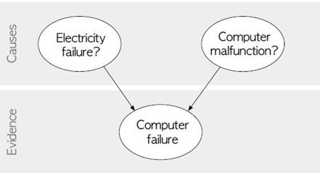

# Data Set:

**Title:** Heart Disease Databases

The Cleveland database contains 76 attributes, but all published experiments refer to using a subset of 14 of them. In particular, the Cleveland database is the only one that has been used by ML researchers to this date. The “Heartdisease” field refers to the presence of heart disease in the patient. It is integer valued from 0 (no presence) to 4.

### Some instance from the dataset:

|  |  |  |  |  |  |  |  |  |  |  |  |  |  |
| --- | --- | --- | --- | --- | --- | --- | --- | --- | --- | --- | --- | --- | --- |
| age | sex | cp | trestbps | chol | fbs | restecg | thalach | exang | oldpeak | slope | ca | thal | Heartdisease |
| 63 | 1 | 1 | 145 | 233 | 1 | 2 | 150 | o | 2.3 | 3 | o | 6 | o |
| 67 | 1 | 4 | 160 | 286 | o | 2 | 108 | 1 | 1.5 | 2 | 3 | 3 | 2 |
| 67 | 1 | 4 | 120 | 229 | o | 2 | 129 | 1 | 2.6 | 2 | 2 | 7 | 1 |
| 41 | o | 2 | 130 | 204 | o | 2 | 172 | o | 1.4 | 1 | o | 3 | o |
| 62 | o | 4 | 140 | 268 | o | 2 | 160 | o | 3.6 | 3 | 2 | 3 | 3 |
| 60 | 1 | 4 | 130 | 206 | o | 2 | 132 | 1 | 2.4 | 2 | 2 | 7 | 4 |

**Program:**

import numpy as np import pandas as pd import csv

from pgmpy.estimators import MaximumLikelihoodEstimator from pgmpy.models import BayesianModel

from pgmpy.inference import VariableElimination

heartDisease = pd.read_csv('7-dataset.csv') heartDisease = heartDisease.replace('?',np.nan)

print('Sample instances from the dataset are given below') print(heartDisease.head())

print('\n Attributes and datatypes') print(heartDisease.dtypes)

model= BayesianModel([('age','heartdisease'),('sex','heartdisease'),('exang','heartdisease'),('cp','heartdisease'),('h eartdisease','restecg'),('heartdisease','chol')])

print('\nLearning CPD using Maximum likelihood estimators') model.fit(heartDisease,estimator=MaximumLikelihoodEstimator)

print('\n Inferencing with Bayesian Network:') HeartDiseasetest_infer = VariableElimination(model)

print('\n 1. Probability of HeartDisease given evidence= restecg') q1=HeartDiseasetest_infer.query(variables=['heartdisease'],evidence={'restecg':1}) print(q1)

print('\n 2. Probability of HeartDisease given evidence= cp ') q2=HeartDiseasetest_infer.query(variables=['heartdisease'],evidence={'cp':2}) print(q2)

**Expected Output:**

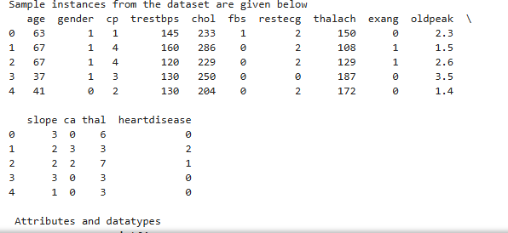

**Result:**

## SIGNATURE OF LAB IN-CHARGE

### Apply EM algorithm to cluster a set of data stored in a .CSV file. Use the same data set for clustering using k-Means algorithm. Compare the results of these two algorithms and comment on the quality of clustering. You can add Java/Python ML library classes/API in the program.

**Aim:** To cluster a set of data using EM algorithm.

### Algorithm/Procedure:

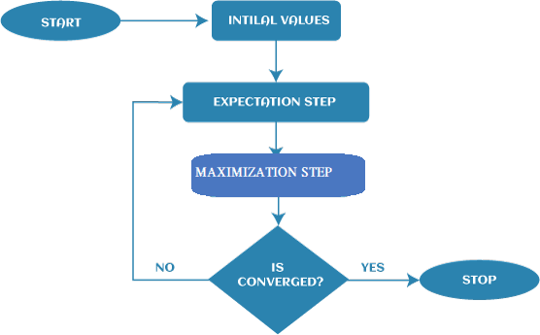

**1st Step:** The very first step is to initialize the parameter values. Further, the system is provided with incomplete observed data with the assumption that data is obtained from a specific model.

**2nd Step:** This step is known as Expectation or E-Step, which is used to estimate or guess the values of the missing or incomplete data using the observed data. Further, E-step primarily updates the variables.

**3rd Step:** This step is known as Maximization or M-step, where we use complete data obtained from the 2nd step to update the parameter values. Further, M-step primarily updates the hypothesis.

**4th step:** The last step is to check if the values of latent variables are converging or not. If it gets "yes", then stop the process; else, repeat the process from step 2 until the convergence occurs.

### Program:

from sklearn.cluster import KMeans

from sklearn.mixture import GaussianMixture import sklearn.metrics as metrics

import pandas as pd import numpy as np

import matplotlib.pyplot as plt

names = ['Sepal_Length','Sepal_Width','Petal_Length','Petal_Width', 'Class'] dataset = pd.read_csv("8-dataset.csv", names=names)

X = dataset.iloc[:, :-1]

label = {'Iris-setosa': 0,'Iris-versicolor': 1, 'Iris-virginica': 2} y = [label[c] for c in dataset.iloc[:, -1]] plt.figure(figsize=(14,7)) colormap=np.array(['red','lime','black'])

# REAL PLOT

plt.subplot(1,3,1) plt.title('Real')

plt.scatter(X.Petal_Length,X.Petal_Width,c=colormap[y]) # K-PLOT

model=KMeans(n_clusters=3, random_state=0).fit(X) plt.subplot(1,3,2)

plt.title('KMeans') plt.scatter(X.Petal_Length,X.Petal_Width,c=colormap[model.labels_])

print('The accuracy score of K-Mean: ',metrics.accuracy_score(y, model.labels_)) print('The Confusion matrixof K-Mean:\n',metrics.confusion_matrix(y, model.labels_)) # GMM PLOT

gmm=GaussianMixture(n_components=3, random_state=0).fit(X) y_cluster_gmm=gmm.predict(X)

plt.subplot(1,3,3) plt.title('GMM Classification')

plt.scatter(X.Petal_Length,X.Petal_Width,c=colormap[y_cluster_gmm]) print('The accuracy score of EM: ',metrics.accuracy_score(y, y_cluster_gmm))

print('The Confusion matrix of EM:\n ',metrics.confusion_matrix(y, y_cluster_gmm))

### Expected Output:

The accuracy score of K-Mean: 0.24 The Confusion matrixof K-Mean:

[[ 0 50 0]

[48 0 2]

[14 0 36]]

The accuracy score of EM: 0.36666666666666664 The Confusion matrix of EM:

[[50 0 0]

[ 0 5 45]

[ 0 50 0]]

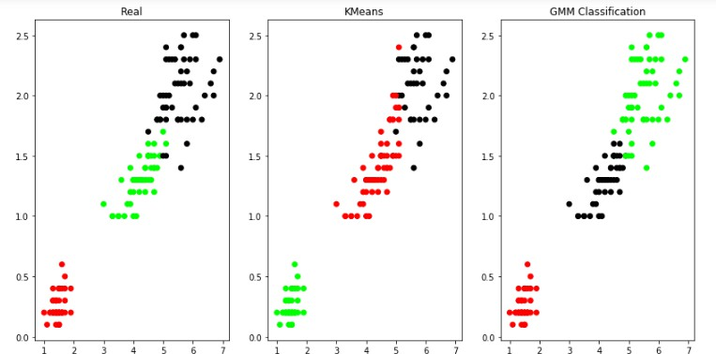

**Result:**

## SIGNATURE OF LAB IN-CHARGE

### Write a program to implement k-Nearest Neighbour algorithm to classify the iris data set. Print both correct and wrong predictions. Java/Python ML library classes can be used for this problem.

**Aim:** To implement k-Nearest Neighbour algorithm to classify the iris data set.

### Algorithm/Procedure:

Training algorithm:

* + For each training example (x, f (x)), add the example to the list training examples Classification algorithm:
    - Given a query instance xq to be classified,
      * Let x1 . . .xk denote the k instances from training examples that are nearest to xq
      * Return

https://www.vtupulse.com/wp-content/uploads/2021/01/image-12.png

* + Where, f(xi) function to calculate the mean value of the k nearest training examples.

# Data Set:

Iris Plants Dataset: Dataset contains 150 instances (50 in each of three classes) Number of Attributes: 4 numeric, predictive attributes and the Class.

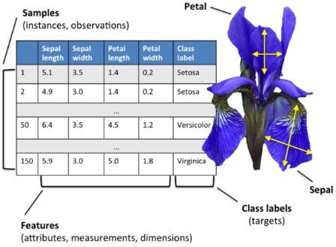

### Program:

import numpy as np import pandas as pd

from sklearn.neighbors import KNeighborsClassifier from sklearn.model_selection import train_test_split from sklearn import metrics

names = ['sepal-length', 'sepal-width', 'petal-length', 'petal-width', 'Class'] # Read dataset to pandas dataframe

dataset = pd.read_csv("9-dataset.csv", names=names) X = dataset.iloc[:, :-1]

y = dataset.iloc[:, -1] print(X.head())

Xtrain, Xtest, ytrain, ytest = train_test_split(X, y, test_size=0.10) classifier = KNeighborsClassifier(n_neighbors=5).fit(Xtrain, ytrain) ypred = classifier.predict(Xtest)

i = 0

print ("\n ")

print ('%-25s %-25s %-25s' % ('Original Label', 'Predicted Label', 'Correct/Wrong')) print (" ")

for label in ytest:

print ('%-25s %-25s' % (label, ypred[i]), end="") if (label == ypred[i]):

print (' %-25s' % ('Correct')) else:

print (' %-25s' % ('Wrong')) i = i + 1

print (" ")

print("\nConfusion Matrix:\n",metrics.confusion_matrix(ytest, ypred)) print (" ")

print("\nClassification Report:\n",metrics.classification_report(ytest, ypred)) print (" ")

print('Accuracy of the classifer is %0.2f' % metrics.accuracy_score(ytest,ypred)) print (" ")

### Expected Output:

sepal-length sepal-width petal-length petal-width

|  |  |  |  |  |
| --- | --- | --- | --- | --- |
| 0 | 5.1 | 3.5 | 1.4 | 0.2 |
| 1 | 4.9 | 3.0 | 1.4 | 0.2 |
| 2 | 4.7 | 3.2 | 1.3 | 0.2 |
| 3 | 4.6 | 3.1 | 1.5 | 0.2 |
| 4 | 5.0 | 3.6 | 1.4 | 0.2 |

Original Label Predicted Label Correct/Wrong

|  |  |  |
| --- | --- | --- |
| Iris-versicolor | Iris-versicolor | Correct |
| Iris-setosa | Iris-setosa | Correct |
| Iris-versicolor | Iris-versicolor | Correct |

|  |  |  |
| --- | --- | --- |
| Iris-setosa | Iris-setosa | Correct |
| Iris-versicolor | Iris-versicolor | Correct |
| Iris-setosa | Iris-setosa | Correct |
| Iris-setosa | Iris-setosa | Correct |
| Iris-virginica | Iris-virginica | Correct |
| Iris-versicolor | Iris-versicolor | Correct |
| Iris-versicolor | Iris-versicolor | Correct |
| Iris-versicolor | Iris-versicolor | Correct |
| Iris-virginica | Iris-virginica | Correct |
| Iris-versicolor | Iris-versicolor | Correct |
| Iris-virginica | Iris-virginica | Correct |
| Iris-setosa | Iris-setosa | Correct |
| Confusion Matrix: |  |  |

[[5 0 0]

[0 7 0]

[0 0 3]]

Classification Report:

|  |  |  |  |  |
| --- | --- | --- | --- | --- |
|  | precision | recall | f1-score | support |
| Iris-setosa | 1.00 | 1.00 | 1.00 | 5 |
| Iris-versicolor | 1.00 | 1.00 | 1.00 | 7 |
| Iris-virginica | 1.00 | 1.00 | 1.00 | 3 |
| accuracy |  |  | 1.00 | 15 |
| macro avg | 1.00 | 1.00 | 1.00 | 15 |
| weighted avg | 1.00 | 1.00 | 1.00 | 15 |
| Accuracy of the | classifer is | 1.00 |  |  |
| **Result:** |  |  |  |  |

## SIGNATURE OF LAB IN-CHARGE

### Implement the non-parametric Locally Weighted Regression algorithm in order to fit data points. Select appropriate data set for your experiment and draw graphs.

**Aim:** To implement the non-parametric Locally Weighted Regression algorithm in order to fit data points.

### Algorithm/Procedure:

1. Read the Given data Sample to X and the curve (linear or non linear) to Y
2. Set the value for Smoothening parameter or Free parameter say τ
3. Set the bias /Point of interest set x0 which is a subset of X
4. Determine the weight matrix using :

Locally Weighted Regression Algorithm in Python - 2

1. Determine the value of model term parameter β using:

Locally Weighted Regression Algorithm in Python -1

1. Prediction = x0*β

### Program:

import matplotlib.pyplot as plt import pandas as pd

import numpy as np

def kernel(point, xmat, k): m,n = np.shape(xmat)

weights = np.mat(np.eye((m))) for j in range(m):

diff = point - X[j]

weights[j,j] = np.exp(diff*diff.T/(-2.0*k**2)) return weights

def localWeight(point, xmat, ymat, k): wei = kernel(point,xmat,k)

W = (X.T*(wei*X)).I*(X.T*(wei*ymat.T)) return W

def localWeightRegression(xmat, ymat, k): m,n = np.shape(xmat)

ypred = np.zeros(m) for i in range(m):

ypred[i] = xmat[i]*localWeight(xmat[i],xmat,ymat,k) return ypred

# load data points

data = pd.read_csv('10-dataset.csv') bill = np.array(data.total_bill)

tip = np.array(data.tip)

#preparing and add 1 in bill mbill = np.mat(bill)

mtip = np.mat(tip)

m= np.shape(mbill)[1] one = np.mat(np.ones(m))

X = np.hstack((one.T,mbill.T))

#set k here

ypred = localWeightRegression(X,mtip,0.5) SortIndex = X[:,1].argsort(0)

xsort = X[SortIndex][:,0]

fig = plt.figure()

ax = fig.add_subplot(1,1,1) ax.scatter(bill,tip, color='green')

ax.plot(xsort[:,1],ypred[SortIndex], color = 'red', linewidth=5) plt.xlabel('Total bill')

plt.ylabel('Tip') plt.show();

**Expected Output:**

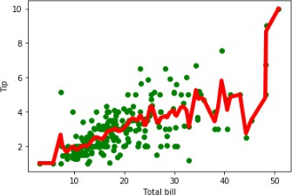

**Result:**

**SIGNATURE OF LAB IN-CHARGE**